Marketing Research
Backpacks.
1)Trail maker Classic 17-inch Backpacks with Adjustable Padded Straps | School Backpacks for Girls, Boys (Coral)
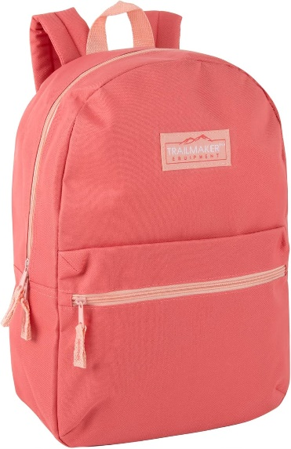
Customer reviews
- 4.2 out of 5 stars

Price
- LKR3,311.68
Colours

- 11 colours are include (Black, White, Blue are main)

Products Details
- CLASSIC BACKPACK: Zipper bag, rucksack, knapsack—whatever you call it, this one is a throwback to vintage style
- COLORFUL BACKPACKS FOR KIDS & ADULTS: Choose from an assortment of green, light blue, grey, pink, coral, khaki, navy, red, & black backpacks with a fun splash of color trim. Each bag has a unique look & personal feel
- DOUBLE ZIPPERS: Easy grip cloth and metal zippers make it twice as easy to open & close your bag in a rush between classes or airport gates, & give you multiple places to hang keychains to showcase your taste & style
- PLENTY OF POCKETS: Roomy main compartment is perfect for laptop or tablet, books, notebooks, and water bottle, while outer front pocket is great for phone, pens, tissues, & snacks. It also secures your keys, cash, & ID
- DIMENSIONS & DETAILS: Simple & modern bookbag measures 17 x 12 x 5.5 inches (43.18 x 30.48 x 13.97cm), & is made of durable, smooth polyester. Hang handle double stitched on top so you can easily store this 20-liter backpack

https://www.amazon.com/Trail-maker-Classic-Backpacks-Adjustable/dp/B0F2NG8JZV/ref=sr_1_2?crid=20PIOZ96YJ5C0&dib=eyJ2IjoiMSJ9.toRlC97OgEdvbIb1sWoMMEcV6sYLhAeMuZ9GxCFfYalKRYsAfpo6ZaMH0h3PcGRclmQKsFkqdyH06sgK00e3ISBd6xZaIs10g3gX_UEZ6NDg5wj90s2RUkGWz3XmaPFIQIGVI5ZRLydotb5pphcPBlVk9gcQiG0YzbWS3s64MklG_k964nxjCwA9cQTdI3t72jJqhZhBn5zesli2pkCOclAbF5SW0DGYRDW-dXr3GvE.ErKtaRU1TIltfULE6wxdenJj--A05hp_djGX-Qdv0tg&dib_tag=se&keywords=backpacks&qid=1780381312&refinements=p_n_g-101015233022111%3A121075133011&rnid=121075130011&sprefix=backpack%2Caps%2C375&sr=8-2&th=1
2)WINDARS School Backpack for Teen Girls, Cute College Backpacks for Women Students Aesthetic Bookbag Large 15.6 Inch Laptop Bag Middle School Travel Back Pack (Khaki Beige)
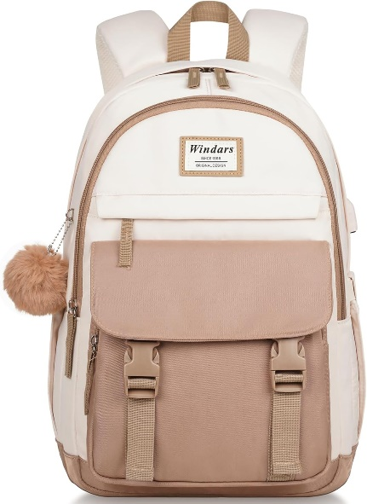

Customer reviews
- 4.7 out of 5 stars

Price
- LKR5,492.96
Colours
- 10 colours
Product Details
- 【Large Capacity & 20 Organized Pockets】: This backpack for school has 4 separate different compartments and two side pockets to meet your daily storage. 1 separate laptop compartment includes laptop padded sleeve with elastic belt. The front tool compartment also comes with multiple pockets to provide roomy space for necessities. The front two pockets can hold charge device and other small items, convenient for your daily organization.
- 【Large Size & Trendy Style】: The size of the backpack aesthetic is 12.6"x8.4"x17.7"(L*W*H), Capacity: 25 liters; Weight: 0.79 kg / 1.74 lbs. The dedicated laptop compartment adding a tablet slot fits for 13.3, 15.6, 16.1-inch laptop and 12.9-inch iPad. This cute backpack for middle school girls is crafted with a unique double buckle and also comes along with a fluffy ball key pendant as a gift, adding a fashionable edge to its practicality.
- 【Comfort & Convenience】: The Widen and thicken durable S-shape straps with good breathability and good heat dissipation are well-padded, adjustable and comfortable to carry. The luggage strap allows this cute backpack to attach to luggage/suitcases, making your journey more convenient. Back hidden anti-theft zippered pocket sits up against the wearer’s body for valuables.
- 【Waterproof Material & USB Charging Port】: Crafted from waterproof, ultra-lightweight, high density premium polyester fabric, light to carry. The zippers closure are used by the premium quality zippers to ensure the long-lasting usage. With built-in charging cable and outside upgraded USB 3.0 charging port, the girls backpack provides a easier way to charge your devices.
- 【For Any Ages & Occasion】: The school bag is stylish enough for casual and student use, while the design provides the multi functionality. Perfect for young teens, girls, ladies. The basic multipurpose back to school backpack meets most of your needs, easy to match your cloths, suitable for short trip, work, shopping, university, school, office, daily use, etc. (Age: over 3 years old.)
https://www.amazon.com/WINDARS-Backpack-Backpacks-Students-Aesthetic/dp/B0D1YB84JX/ref=sr_1_4?crid=20PIOZ96YJ5C0&dib=eyJ2IjoiMSJ9.toRlC97OgEdvbIb1sWoMMEcV6sYLhAeMuZ9GxCFfYalKRYsAfpo6ZaMH0h3PcGRclmQKsFkqdyH06sgK00e3ISBd6xZaIs10g3gX_UEZ6NDg5wj90s2RUkGWz3XmaPFIQIGVI5ZRLydotb5pphcPBlVk9gcQiG0YzbWS3s64MklG_k964nxjCwA9cQTdI3t72jJqhZhBn5zesli2pkCOclAbF5SW0DGYRDW-dXr3GvE.ErKtaRU1TIltfULE6wxdenJj--A05hp_djGX-Qdv0tg&dib_tag=se&keywords=backpacks&qid=1780381312&refinements=p_n_g-101015233022111%3A121075133011&rnid=121075130011&sprefix=backpack%2Caps%2C375&sr=8-4&th=1

3)Lohol Water Resistant Daypack with Multiple Pockets for School Travel Outdoor College, 15.6-inch Laptop Backpack for Men and Women (Black)
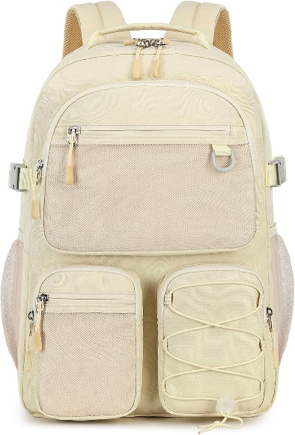
Customer reviews
- 4.7 out of 5
Price
- LKR12,925.18
Colours
- 14 colours
Products Details
- [Durable & Lightweight] - The big backpack is made of water-resistant polyester fabric with metal zippers. It is lightweight only 1.56lb, Great for casual daily use, school and travel.
- [Large Capacity] - Size: 12.4×6.7×17.3 inches, it is large enough to carry everything you need. The main room contain 15.6 Inch laptop compartment can hold textbook, tablet, books, clothes and other necessities.
- [Multi Pockets] - The multi front pocket allows you to put your small items in an organized manner. Side pockets for water bottle or umbrella. Large middle sub pocket for magazines, A4 documents, etc.
- [Comfortable] - The shoulder starp is adjustable, you can adjust the length that suits yourselves, and luggage strap allows backpack fit on luggage/suitcase, slide over the luggage upright handle tube for easier carrying.
- [Multi Usage] - The casual daypack is unisex and suitable for various activities, including school, travel, college, work, outdoor activities, and daily use, etc.

https://www.amazon.com/Lohol-Resistant-Daypack-Mulitiple-Backpack/dp/B0C5SNDG7W/ref=sr_1_15?crid=20PIOZ96YJ5C0&dib=eyJ2IjoiMSJ9.toRlC97OgEdvbIb1sWoMMEcV6sYLhAeMuZ9GxCFfYalKRYsAfpo6ZaMH0h3PcGRclmQKsFkqdyH06sgK00e3ISBd6xZaIs10g3gX_UEZ6NDg5wj90s2RUkGWz3XmaPFIQIGVI5ZRLydotb5pphcPBlVk9gcQiG0YzbWS3s64MklG_k964nxjCwA9cQTdI3t7yB25OWKTwmKxt1MmHwljd2uiAQeGIulWXld6SRBfWTQ.AbjdNUX-fYxu4Ki-VE9eGgJeQIMf_qItgGg9yFKhK5c&dib_tag=se&keywords=backpacks&qid=1780384905&refinements=p_n_g-101015233022111%3A121075133011&rnid=121075130011&sprefix=backpack%2Caps%2C375&sr=8-15&th=1

4)Maxi Travel Laptop Backpack, Lightweight Durable School Bookbag Men Woman 15.6" Computer Bag, Water Resistant Outdoor Hiking Backpacks with Multifunction Pockets, Beige
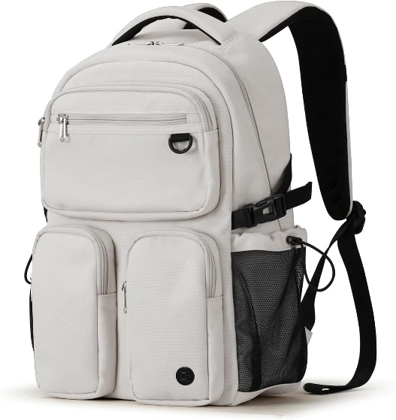
Customer reviews
- 4.4 out of 5
Price
- LKR16,571.68
Size
- 16 inches
Colours
- 4 colours

Products Details
- 【MULTI COMPARTMENTS This backpack features one main zipped compartment, three zipped front pockets and two side pockets. The main compartment provide one dedicated laptop padding compartment hold 15.6-inch laptop, two side pockets are good for holding water bottles and umbrellas. Well organized and convenient access to your essentials.
- 【DURABLE The backpack is made with high quality tear and water-resistant material, provides extra strength and long-lasting performance with the lightest weight possible. YKK zipper is smooth and durable for a longer usage time.
- 【BREATHABLE & COMFORTABLE 】Comfortable wide breathable mesh S shaped shoulder straps help relieve the stress from your shoulder for long time wear. The top handle is perfect for when you want to carry your bag and give your shoulders a break.
- 【OVERALL DIMENSION】 The backpack external dimensions is 11.02 x 5.12 x 16.93 inch. A luggage strap in the back which can trap the suitcase telescopic handle, so that you can free your shoulders and hands when travel.

https://www.amazon.com/Mixi-Lightweight-Resistant-Backpacks-Multifunction/dp/B0BB12LP4K/ref=pd_rhf_se_s_pd_sbs_rvi_d_sccl_2_5/132-4675774-5304404?pd_rd_w=SmRfq&content-id=amzn1.sym.6640a844-ab24-4352-ac9b-78899e683a5e&pf_rd_p=6640a844-ab24-4352-ac9b-78899e683a5e&pf_rd_r=T493QDFEEN6Z5SQD3JZB&pd_rd_wg=k2WML&pd_rd_r=376fc31f-5a7a-44e8-a13e-28bd1b5b5cb1&pd_rd_i=B0BB12LP4K&th=1

5)Classic Casual Backpack, Lightweight Daypack with 10 Pockets, Laptop Compartment, EVA Foam Pad (Black)
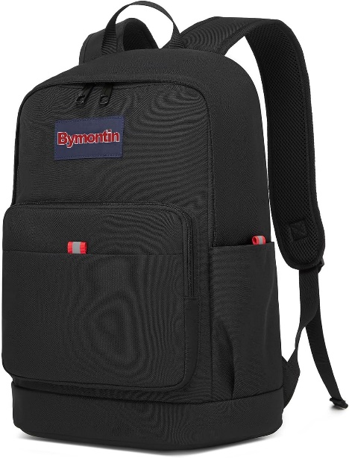
Customer reviews
- 4.4 out of 5
Price
- LKR4,969.189 (LKR 29,811.80 Shipping & Import Charges to Sri Lanka)
Colours
- 4 colours
Products Details
- Classic Everyday Backpack — Bymontin 1930 is designed for daily life: school, commuting, shopping, short trips, or as an extra bag in your car. Simple, versatile, and ready for any casual occasion.
- Smart Storage, 10 Pockets — Organize easily with 10 pockets and compartments. Keep your laptop, books, gadgets, water bottle, and daily essentials in place and within reach.
- Laptop Protection — Features a padded main compartment with EVA Foam Pad to keep your laptop safe and secure during daily commute or travel.
- Lightweight & Durable — Made with sturdy, wear-resistant fabric that stays comfortable on your shoulders all day. The affordable choice that doesn’t compromise on quality.
- Unisex & Timeless Style — Classic casual look for students and young adults. Matches any outfit, any day, anywhere. A reliable everyday backpack for everyone.
- Please hand wash the backpack before first use and allow it to air dry completely.

https://www.amazon.com/Bymontin-Classic-Backpack-Lightweight-Compartment/dp/B0FHJWTCY4/ref=pd_rhf_se_s_pd_sbs_rvi_d_sccl_2_6/132-4675774-5304404?pd_rd_w=SmRfq&content-id=amzn1.sym.6640a844-ab24-4352-ac9b-78899e683a5e&pf_rd_p=6640a844-ab24-4352-ac9b-78899e683a5e&pf_rd_r=T493QDFEEN6Z5SQD3JZB&pd_rd_wg=k2WML&pd_rd_r=376fc31f-5a7a-44e8-a13e-28bd1b5b5cb1&pd_rd_i=B0FHJWTCY4&th=1

6)WINDARS Backpack for School Girls, Cute High School Backpacks for Teens Women Student Large Bookbag 15.6 Inch Laptop Bag with USB Charger Port for College Work Travel Trip (Khaki Beige)
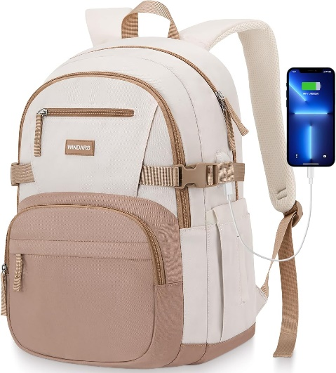
Customer reviews
- 4.8 out of 5
Price
- LKR9,278.68
Size
- 15.6 inch
Color
- Beige Khaki
Products Details
- [Multi-compartments & Large Capacity]: Total 3 compartments: 1 main compartment with padded laptop sleeve provide roomy space for your 15.6 Inch laptop, 12.9" iPad, A4 folder, books, clothes, phone charger cable, etc. 1 secondary compartment for your pens, highlighters and stationery. 1 front compartment for notebook and other college supplies. There are also two water bottle pockets on both sides for drinks.
- [Comfort & Convenience]: The Widen and thicken adjustable S-shape shoulder straps with good breathability and good heat dissipation are well-padded to relieve shoulder pressure to reduce discomfort. With a luggage strap on the back, it allows the backpack to securely fit on the handle of a rolling suitcase - making your journey and travelling more convenient wherever you go. Back hidden anti-theft zippered pocket sits up against the wearer’s body to store your valuables.
- [Waterproof Material & USB Charging Port]: Made with durable water-resistant oxford fabric. With built-in charging cable and outside upgraded USB 3.0 charging port, the cute bookbag provides a more convenient and easier way to charge your devices. No need to keep power bank on the hand, make life easier.
- [Large Size & Laptop Protection]: Big Student Backpack for girls, women, measuring 17.5"x7.5"x11.8"(H*W*L), Capacity: 25 liters. The dedicated laptop sleeve and tablet pocket comes with an elastic belt which can offer the optimal protection for your 15.6’’ laptop and 12.9’’ iPad.
- [Multi-use & Occasion]: Classic and stylish design makes the waterproof school back pack enough for casual and student use, while the multi-pocket design makes your items organized and easier to find. Perfect for young teens, girls, women, ladies. The basic multipurpose backpacks for school girls meets most of your needs, easy to match your cloths, suitable for short trip, work, shopping, university, school, office, daily use, etc. (Age: over 3 years old.)

https://www.amazon.com/WINDARS-Backpack-Backpacks-Student-Bookbag/dp/B0D3HXDW78/ref=pd_rhf_se_s_pd_sbs_rvi_d_sccl_2_1/132-4675774-5304404?pd_rd_w=SmRfq&content-id=amzn1.sym.6640a844-ab24-4352-ac9b-78899e683a5e&pf_rd_p=6640a844-ab24-4352-ac9b-78899e683a5e&pf_rd_r=T493QDFEEN6Z5SQD3JZB&pd_rd_wg=k2WML&pd_rd_r=376fc31f-5a7a-44e8-a13e-28bd1b5b5cb1&pd_rd_i=B0D3HXDW78&th=1
7)PRAGARI Cute Backpack for School Girls Aesthetic Backpack Women College Bookbag Large Students Laptop Bag Travel Casual Daypack
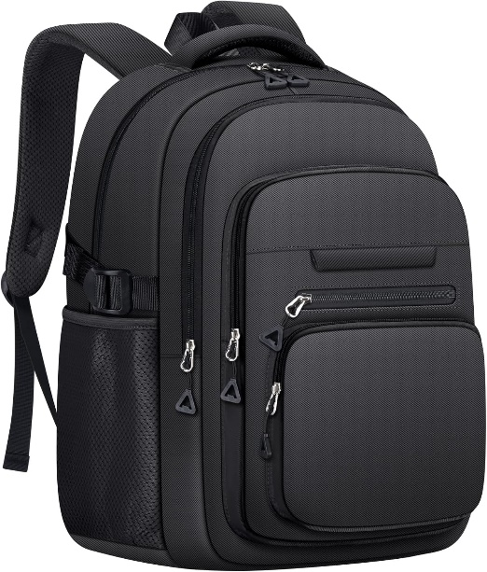
Customer reviews
- LKR7,286.37
      - Price - LKR 33,667.14 Shipping & Import Charges to Sri Lanka
      - Colours - 4 colours
Products Details
- [High Quality Material]: Our preppy backpack is made of ultra-lightweight and high-density nylon fabric and polyester lining. It is not only lightweight yet strong construction, but also easy to clean. Zipper of this kids school backpack is made of high quality with well-made and firmly sewn. The two-way zipper design provides you with a smoother and more flexible opening and closing experience. With this girls school backpacks, you will enjoy its fashion and convenience everywhere.
- [Size]: Measuring 12.6in(L)*6.7in(W)*17.3in(H). This college backpack has multiple pockets for organization. 1 spacious main compartment includes 1 padded tablet sleeve and 2 small inside pockets. 4 exterior zippered front pockets and 2 side pockets allow you to better categorize your other belongings. 1 back safe zippered pocket for secure storage of important items. The luggage strap on the back of the girls bookbag can be mounted on a suitcase to make your traveling more convenient.
- [Exquisite Design]: The kids bookbag adopts soft adjustable sturdy shoulder straps to reduce the press on your shoulder and wear comfortably. The S-curve design fits perfectly on the shoulders, while the honeycomb ventilated material prevents discomfort from the heat. Thick and multi-layer padding of the teen girl backpack provides additional back support. Moreover, the reinforced seams strengthen the connection between the shoulder straps and the large backpack, enhancing its sturdiness.
- [For Any Ages & Occasion]: This college bookbag is a perfect companion for both outdoor and indoor activities. Whether it's for daily use, school, commuting, weekend vacations, short hikes, or camping trips, this cute college backpack is suitable for all. The simple and generous design and the bright color combination make the womens backpack full of youthful vitality. Age: over 6 years old.
https://www.amazon.com/PRAGARI-Backpack-Aesthetic-College-Students/dp/B0DPRSL6LV/ref=sxin_17_pa_sp_search_thematic-asin_sspa?content-id=amzn1.sym.f54ebb28-8a09-41df-b2d9-ffd8e993b956%3Aamzn1.sym.f54ebb28-8a09-41df-b2d9-ffd8e993b956&crid=20PIOZ96YJ5C0&cv_ct_cx=backpacks&keywords=backpacks&pd_rd_i=B0DPRSL6LV&pd_rd_r=bfc89c10-feee-46c0-9de9-ef3237edb665&pd_rd_w=YkdPP&pd_rd_wg=tc2IY&pf_rd_p=f54ebb28-8a09-41df-b2d9-ffd8e993b956&pf_rd_r=9Q5TZYY7VNYMWJR2MZK0&qid=1780387089&refinements=p_n_g-101015233022111%3A121075136011&rnid=121075130011&sbo=RZvfv%2F%2FHxDF%2BO5021pAnSA%3D%3D&sprefix=backpack%2Caps%2C375&sr=1-2-925d4041-2745-4edd-b995-62e9e595df4e-spons&aref=FQA0lliEmK&sp_csd=d2lkZ2V0TmFtZT1zcF9zZWFyY2hfdGhlbWF0aWM&th=1

8)BAGSMART College Laptop Backpack, Travel Backpack for Women, Quilted Casual Daypack, Water-Resistant Bookbag for 15.6 Inch Laptop, Camel
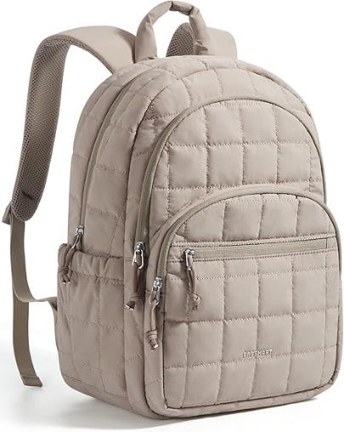
Customer reviews
- 4.6 out of 5
Price
- LKR8,449.94( LKR 35,304.75 Shipping & Import Charges to Sri Lanka)
Colours
- 12 colours
Products Details

- STYLE MEETS FUNCTIONALITY: Our women's backpack combines style and practicality, you don't have to compromise on fashion for functionality which allows you to showcase your unique style while comfortably carrying all your essentials. Dimensions:17.3×11.8×7.9 inches
- AMPLE COMPARTMENTS: Stay organized and prepared with the BAGSMART Laptop backpack. With its thoughtfully designed compartments, you can easily separate and store your 15.6" laptop, books, supplies, and more. No more searching for items in a cluttered bag - everything has its place.
- ENHANCED COMFORT: The padded straps ensure an even distribution of weight, while the breathable mesh on the backside keeps you cool and provides ergonomic support for your back. Even when filled with heavy books and supplies, you can enjoy a comfortable carrying experience
- VERSATILE ALL-IN-ONE BACKPACK: TSA Friendly, the strap on backside allows easy slides over suitcase handle, perfect for work, business, college, teacher, nurse, travel, weekend getaways or daily use, BAGSMART backpack is a reliable companion, a real essential backpack you must have
- EXCELLENT QUALITY: The BAGSMART Water-Resistant College Backpack is crafted from soft and durable Taslon fabric, ensuring it withstands daily wear and tear. The smooth and sturdy zipper guarantees long-term use. Making it a reliable choice that will last throughout the college year and beyond.
https://www.amazon.com/BAGSMART-College-Backpack-Quilted-Water-Resistant/dp/B0DQSJM8SX/ref=sr_1_3?crid=20PIOZ96YJ5C0&dib=eyJ2IjoiMSJ9.EnmWB-lmiap5mRI7b47TsPIDasuVmvL_DmlyNHbXYTg2p6SIAHtiPR_7hLp6y3nOhacSK7Hp9oJqiCiinM9X4w97LR3NmlQJrrOGssugE-vicYVko_6awzlSEBlhsW2AjR-gRQwANMCLKjf3oYNHdbD1TOF-7D9ENm6w0h7_B3KDDrWFyF50gKQiRZYiZoVvRmTAthh6-sCCUEQeHRvBc88T0jporGkOgwIl4guUMNQ.2k2GJBnQg4GE5ruCBnHuu16evFVnLZ5_bYX4oP55ObI&dib_tag=se&keywords=backpacks&qid=1780387447&refinements=p_n_g-101015233022111%3A121075131011%7C121075136011&rnid=121075130011&sprefix=backpack%2Caps%2C375&sr=8-3&th=1
9)LOVEVOOK Laptop Backpack for Women, 15.6 Inch Work Business Backpacks Purse With Large Capacity, Waterproof Nurse Bag College Bookbag for School, Waterproof Casual Daypack for Travel
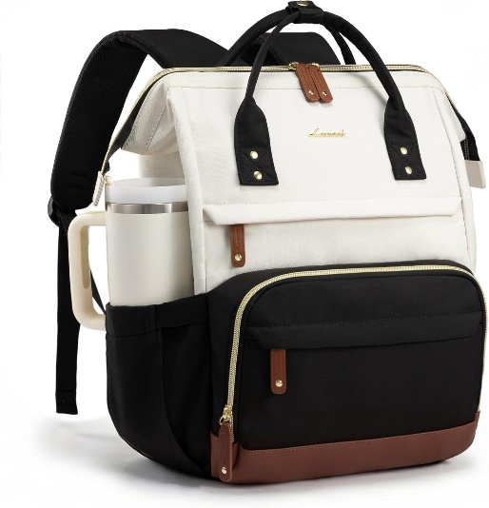
Customer reviews
- 4.8 out of 5
Price
- LKR7,949.37 (LKR 38,129.13 Shipping & Import Charges to Sri Lanka)
Colours
- 20 colours
Products Details
- 【WIDE-OPEN RECTANGULAR FRAME FOR QUICK ACCESS】 Engineered with a structured steel frame opening (7.5" width), this teacher backpack stays fully open on its own, allowing instant visibility of contents without digging. The rigid top design transforms it from a slouchy sack into a professional work bag, making it easy to retrieve grade books or medical charts. Ideally suited as a nurse bag for work or a daily carry for educators who need organization during busy classroom transitions.
- 【ELASTICIZED SIDE POCKETS FOR 40oz TUMBLERS】 Featuring deep, upgraded elastic side pockets, this travel backpack for women securely accommodates large hydration vessels, including the popular 40oz tumbler and oversized water bottles. The high-tension fabric prevents bottles from falling out during sprints to catch a train or flight. A practical hydration solution for nursing students on long shifts or commuters who require easy access to coffee and water.
- 【15.6-INCH PADDED LAPTOP COMPARTMENT】 Designed as a protective laptop backpack, it features a dedicated tech compartment with thickened foam walls that fits up to a 15.6-inch laptop (including HP, Dell, and Lenovo models). The vertical cushioning acts as a shock absorber against daily bumps on the subway or bus. An essential commuter backpack feature for office professionals and college students needing reliable device protection during rush hour travel.
- 【MULTI-COMPARTMENT CLINICAL BAG ORGANIZATION】 This large capacity backpack utilizes a smart 3-compartment system to separate bulky textbooks, binders, and clinical gear. The interior includes specialized slots for pens, tablets, and personal items, functioning perfectly as a clinical bag for nursing school or a mobile workstation. Includes a hidden anti-theft back pocket to secure passports and phones, providing peace of mind in crowded public spaces.
- 【TSA-FRIENDLY LUGGAGE STRAP FOR TRAVEL】 Built for business efficiency, this carry on backpack features a sturdy rear luggage strap that slides over suitcase handles for hands-free airport navigation. Its dimensions are optimized to fit under standard airline seats, serving as a perfect personal item travel bag. The breathable mesh shoulder straps reduce fatigue, making it the ultimate choice for weekend getaways and international business trips.

https://www.amazon.com/LOVEVOOK-Backpack-Backpacks-Waterproof-Black-White-Brown/dp/B0BPX6DNRG/ref=sr_1_9?crid=20PIOZ96YJ5C0&dib=eyJ2IjoiMSJ9.EnmWB-lmiap5mRI7b47TsPIDasuVmvL_DmlyNHbXYTg2p6SIAHtiPR_7hLp6y3nOhacSK7Hp9oJqiCiinM9X4w97LR3NmlQJrrOGssugE-vicYVko_6awzlSEBlhsW2AjR-gRQwANMCLKjf3oYNHdbD1TOF-7D9ENm6w0h7_B3KDDrWFyF50gKQiRZYiZoVvRmTAthh6-sCCUEQeHRvBc88T0jporGkOgwIl4guUMNQ.2k2GJBnQg4GE5ruCBnHuu16evFVnLZ5_bYX4oP55ObI&dib_tag=se&keywords=backpacks&qid=1780387447&refinements=p_n_g-101015233022111%3A121075131011%7C121075136011&rnid=121075130011&sprefix=backpack%2Caps%2C375&sr=8-9&th=1

10)LOVEVOOK Travel Backpack for Women, 40L Carry on Backpack Flight Approved, TSA Personal Item Travel Bag Fits 17 Inch Laptop, Business Weekender Overnight Waterproof Daypack With 2 Cubes, Grey-Pink
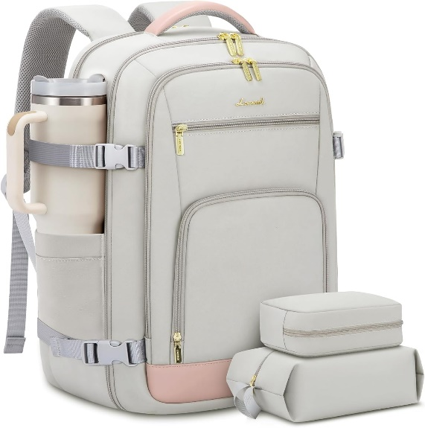
Customer reviews
- 4.8 out of 5
Price
- LKR12,593.68
LKR 45,070.74 Shipping & Import Charges to Sri Lanka

Colours
- 20 colours
Products Details
- Airline Approved & TSA Friendly : Experience stress-free air travel with our carry on backpack. Measuring 14" x 8.3" x 18.5", it fits comfortably in overhead bins and under the seat. Designed for quick security checks, it opens 180 degrees, making it the perfect travel companion for your journeys.
- Large Capacity With Great Organization : This travel backpack boasts a generous 40L capacity, perfect for 3-5 days of travel essentials. 3 Big compartments and 18 pockets, ensuring everything is neatly organized. A dedicated and padded compartment fits a 17.3-inch laptop for maximum safety. The elastic band water bottle pocket securely holds a 500ml bottle. This versatile construction design makes this backpack perfect for travel, business trips, weekend getaways, and everyday use.
- Sturdy & Comfortable : Upgraded with explosion-proof zippers and water-resistant fabric, this backpack is built for longevity. Its reinforced, tear-resistant shoulder straps and breathable sponge padding ensure comfort and longevity. It's perfect as a carry on backpack for airplanes, day trip weekender overnight backpack, camping hiking backpack, business backpack, commuting work backpack, college backpack, or casual daypack.
- With 2 Packing Cubes & Wet Pocket : Our travel backpack for women equipped with 1 carry-on pocket, deal for neatly storing underwear, socks, and small clothes. And equipped one shoe bag with 16.5 inches/42cm long, can hold 1~2 pair of shoes. The high-density waterproof wet pocket is perfect for toiletries and damp clothes, keeping your travel belongings tidy and separated.
- Ideal Gift for Travel Enthusiasts : The LOVEVOOK backpack for women travel bag is a perfect gift for birthdays, Thanksgiving, Christmas, New Year, and Valentine's Day. Suitable for men and women, wife, girlfriend, mother, daughter, and friends, it's a versatile companion as a travel backpack carry on flight approved, travel laptop backpack, or personal item pack.

https://www.amazon.com/LOVEVOOK-Travel-Backpack-Women-40L/dp/B0CLVBFRX1/ref=sr_1_15?crid=20PIOZ96YJ5C0&dib=eyJ2IjoiMSJ9.EnmWB-lmiap5mRI7b47TsPIDasuVmvL_DmlyNHbXYTg2p6SIAHtiPR_7hLp6y3nOhacSK7Hp9oJqiCiinM9X4w97LR3NmlQJrrOGssugE-vicYVko_6awzlSEBlhsW2AjR-gRQwANMCLKjf3oYNHdbD1TOF-7D9ENm6w0h7_B3KDDrWFyF50gKQiRZYiZoVvRmTAthh6-sCCUEQeHRvBc88T0jporGkOgwIl4guUMNQ.2k2GJBnQg4GE5ruCBnHuu16evFVnLZ5_bYX4oP55ObI&dib_tag=se&keywords=backpacks&qid=1780387447&refinements=p_n_g-101015233022111%3A121075131011%7C121075136011&rnid=121075130011&sprefix=backpack%2Caps%2C375&sr=8-15&th=1

